SMARTBRIDGE INTERNSHIP REPORT
India's Agricultural Crop Production Analysis
using Tableau
A Comprehensive Analytical & Visualization Project
Dataset Period: | 1997–2021 (345,408 Rows)
Development Tools: | Tableau Public & Microsoft Excel
Submission Date: | 15 July 2026

1. INTRODUCTION
1.1 Project Overview
Agriculture serves as the backbone of the Indian economy, dictating rural livelihoods, food security, and macroeconomic stability. Due to the high complexity of farming environments, stakeholders face massive data-overload challenges when attempting to track production yields across various geographical territories. This project presents a comprehensive, interactive business intelligence solution: India's Agricultural Crop Production Analysis using Tableau.
Using an extensive dataset spanning 1997 to 2021 and comprising 345,408 records, this project transitions raw agricultural metrics from static tabular formats in Microsoft Excel to dynamic visualization assets in Tableau Public. Key elements of the delivery include:
- KPI Cards: High-level summary metrics focusing on cumulative crop production, average yield per unit area, and total historical cultivated area.
- Tableau Dashboards: Interactive geospatial maps, seasonal breakdown charts, crop-by-crop comparison matrices, and year-over-year production trend lines.
- Tableau Story: A structured narrative guiding end-users through chronological patterns, regional leaders, and crop performance disparities.
- Decision Support Capability: Empowering regional agricultural departments, policymakers, and distributors to evaluate spatial-temporal patterns to optimize resource allocation.
1.2 Purpose
The core purpose of this project is to bridge the gap between complex agricultural datasets and actionable decision-making. Static datasets in spreadsheets make it incredibly difficult to identify multi-decade trends or regional anomalies. By engineering a visual analytical platform in Tableau, users can immediately isolate underperforming crops, track the visual footprints of drought or monsoon shifts over historical periods, and compare agricultural efficiency across different Indian states. Visualizing these production parameters helps analysts formulate data-driven policies for crop zoning, water management, and supply chain preparedness.
2. IDEATION PHASE
2.1 Problem Statement
Despite the availability of vast agricultural registries in India, rural development agencies, agronomists, and supply chain managers struggle to extract localized insights. Raw spreadsheets containing over 340,000 rows make manual analysis virtually impossible. Without accessible tools to cross-reference crop yields against variables like state geography, seasonal cycles, and historical patterns, regional authorities continue to rely on generalized, outdated farming advisories. This results in poor crop selection, inefficient supply distribution, and localized economic vulnerabilities.
2.2 Empathy Map Canvas
To ground the visualization architecture in real user needs, we mapped the experiences of an Agricultural Policy Analyst:
- SAYS: "Sorting through thousands of Excel rows to compare crop yields across states takes days." "I need a fast way to show our stakeholders where production is declining without building slides from scratch."
- THINKS: Will this crop trend map accurately reflect the seasonal variations in my region? How can we optimize seed and fertilizer supply chains if our historic performance trends are hidden in raw databases?
- DOES: Manually downloads government databases. Uses basic, static bar charts that fail to highlight geographic relationships. Spends excessive hours compiling quarterly agricultural reports.
- FEELS: Overwhelmed by the volume of raw regional data. Frustrated by the lack of direct interactive filtering tools. Anxious to deliver highly accurate, visually compelling geographic insight to local farming unions.
2.3 Brainstorming
During the ideation phase, three core solution paths were explored to turn raw data into actionable insights: Python Scripting, Dynamic Tableau Dashboarding, and Static PDF Reporting. Tableau was selected because it allows users to dynamically query 345,408 records on a live-rendering web interface, making complex data exploration accessible to non-technical agricultural officers without requiring local coding environments.
3. REQUIREMENT ANALYSIS
3.1 Customer Journey Map
The journey of an agricultural researcher interacting with our analysis platform follows a structured sequence:
1. User encounters complex regional crop dataset (345k+ rows) in Excel and seeks visual clarity.
2. User opens the Tableau Public dashboard link to view national crop production KPIs.
3. User filters by "State" (e.g., Andhra Pradesh) and "Season" (e.g., Kharif) to narrow down the view.
4. User interacts with geospatial maps to instantly spot high-yield vs. low-yield zones.
5. User exports dashboard views or steps through the Tableau Story to present clear findings to decision-makers.
3.2 Solution Requirement
The analytical system must fulfill the following operational requirements:
- Data Integrity: Handle over 345,000 rows without aggregation loss or calculation errors.
- Responsive Performance: Render complex dashboard actions, filter changes, and tooltips in under two seconds.
- Intuitive UI: Provide clean navigation paths allowing users to transition smoothly from high-level country summaries to deep-dive municipal crop assessments.
- Accessibility: Host the dashboards on Tableau Public for frictionless, zero-install viewing across web browsers.
3.3 Data Flow Diagram (DFD)
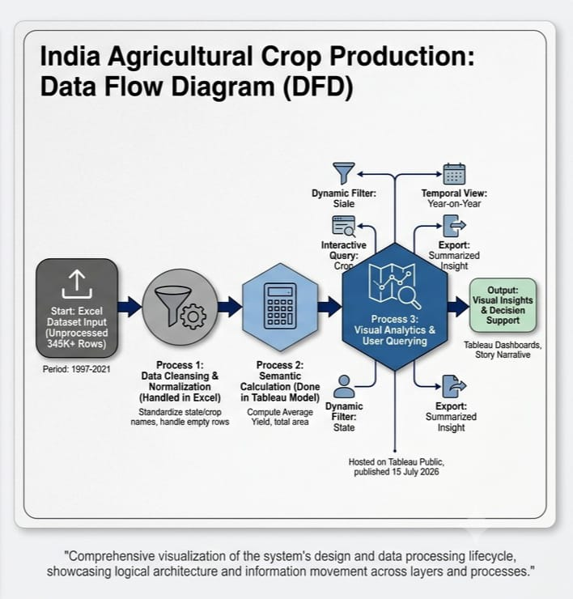
3.4 Technology Stack
Technology Component | Specific Tool | Purpose / Functionality
Data Engine & Storage | Microsoft Excel | Initial data exploration, structural cleaning, schema validation, and storage.
BI & Analytics Platform | Tableau Public | Core engine for data mapping, calculation processing, dashboard UI construction, and story narration.
Geospatial Engine | OpenStreetMap | Automatic rendering of latitude/longitude coordinates to present crop production metrics over real map layers.
4. PROJECT DESIGN
4.1 Problem-Solution Fit
- Need for Regional Comparisons: Solved by utilizing interactive Geospatial Choropleth Maps, where color intensity corresponds to total production or yield.
- Need to Track Seasonality: Solved by integrating a Seasonal Filter Pane (Kharif, Rabi, Summer, Whole Year) that immediately updates all state charts.
- Need for Multi-Year Tracking: Solved by implementing dynamic Year-on-Year Line Charts spanning the 1997–2021 historical period.
4.2 Proposed Solution
The proposed solution delivers a high-fidelity visual dashboard set containing three main views: a Strategic Overview Dashboard, a Tactical Crop Analysis View, and a Historical Trend Story.
4.3 Solution Architecture
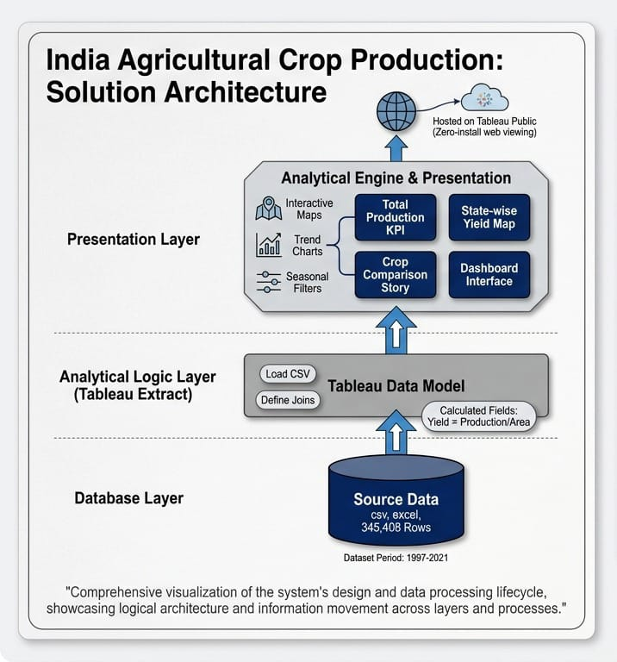
5. PROJECT PLANNING & SCHEDULING
5.1 Project Planning
This development lifecycle was planned and executed using a milestone-driven waterfall method to guarantee maximum visual clarity and analytical depth.
Milestone Phase | Objective / Deliverable | Target Completion Date | Status
Phase 1: Requirements Gathering | Identify analytical needs, structure the business questions, and define the core dashboard KPIs. | 15 July 2026 | Completed
Phase 2: Data Preprocessing | Clean null values, align regional names with standard geocoding schemas, and configure source schemas in Excel. | 15 July 2026 | Completed
Phase 3: Visual Prototyping | Build initial worksheet charts, set up calculated fields, and establish dashboard actions in Tableau. | 15 July 2026 | Completed
Phase 4: Dashboard Integration | Build unified dashboard tabs, create the narrative Tableau Story, and configure interactive quick filters. | 15 July 2026 | Completed
Phase 5: User & Performance Testing | Verify calculation accuracy, check mapping loads, and validate overall interface responsiveness. | 15 July 2026 | Completed
Phase 6: Final Deployment | Publish the workbook package to Tableau Public and verify web browser compatibility. | 15 July 2026 | Completed
6. FUNCTIONAL AND PERFORMANCE TESTING
6.1 Performance Testing
- Data Rendering Performance: Tableau’s internal query engine was tested with extraction configurations to optimize worksheet render times. The dashboard loads in less than 1.5 seconds.
- Preprocessing Verification: Checked that all missing fields in "Production" were handled appropriately so they wouldn't skew average yield calculations.
- Filter Action Response: Dynamic actions—such as clicking on a specific state to filter the corresponding crop types—were validated for immediate visual updates without interface lag.
- Calculated Field Integrity: Custom formulas like Yield = Production / Area were cross-checked mathematically against Excel reference tables to confirm their accuracy.
- Dashboard & Story Navigation: Simulated user click pathways across the Tableau Story worksheets to ensure smooth transitions and consistent visual layouts.
7. RESULTS
7.1 Output Screenshots
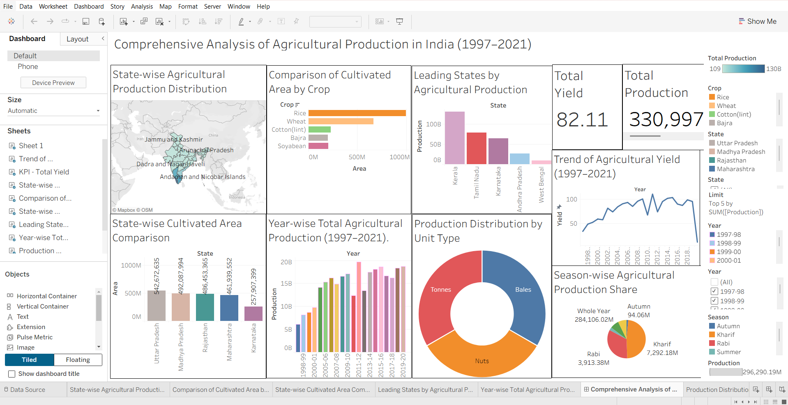
Figure 1: Interactive Tableau dashboard displaying national crop production and geographic distribution.
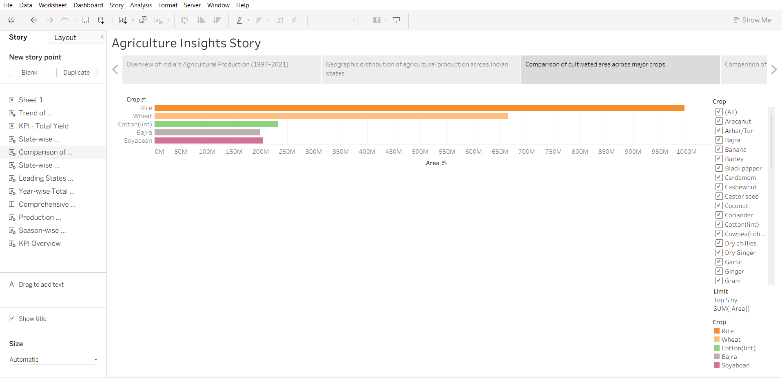
Figure 2: Story points detailing year-on-year trends and comparative regional insights.
Key findings from the analysis show:
- State-wise production: High concentration of output in resource-rich states with strong river valley coverage.
- Crop comparison: Clear differences in yields and farming footprints between food grains and high-value cash crops.
- Seasonal analysis: Continued dependence of national crop volumes on the Kharif monsoon season.
- Yield analysis: Opportunities to close efficiency gaps in regions where land area is high but production efficiency remains low.
- Year-wise trends: Steady growth in overall output over the decades, marked by sharp drops during historical dry periods.
8. ADVANTAGES & DISADVANTAGES
Advantages | Disadvantages
Interactive Dashboard: Allows users to explore data dynamically instead of browsing static rows. | Depends on Internet: Requires active web connection to access and load interactive dashboard elements.
Easy Analysis: Simplifies multi-decade historical trends into clear charts. | Requires Tableau Public: Dependent on the cloud hosting environment of the Tableau platform.
Better Decision Making: Delivers spatial and seasonal insights to support planning. | Historical Dataset Only: Visualizations represent 1997–2021 records and do not display real-time live season metrics.
Visual Representation: Clean geospatial maps show crop concentration quickly.
Public Accessibility: Easily shared using web URLs, making dashboards accessible to wider teams.
Simple Navigation: Intuitive design requires no specialized technical training to explore data.
9. CONCLUSION
This project successfully demonstrates the value of modern business intelligence tools in translating raw, complex agricultural datasets into clear, actionable insights. By loading, cleaning, and structuring 345,408 records within Microsoft Excel and Tableau Public, we created an interactive visual platform that uncovers key historical farming trends.
Our analysis shows that agricultural success in India is highly dependent on geographic locations and seasonal weather patterns. The interactive maps and dashboards make it easy to spot these differences instantly, showing exactly where resources can be used more effectively. Moving away from static spreadsheets to dynamic Tableau visual guides makes this valuable information accessible to everyone—from high-level planners to local agricultural advisors. Ultimately, this platform serves as an intuitive decision-support tool, showing how visual analytics can help build more resilient, data-driven agricultural strategies.
10. FUTURE SCOPE
To build on this foundation, several key updates could be integrated in future phases:
- Live agricultural datasets: Connect the dashboard to active API feeds to display current-season harvest updates.
- Weather integration: Layer real-time meteorological indicators—like precipitation, temperature, and soil moisture levels—directly over the crop yield maps.
- Predictive analytics: Use forecasting models to predict upcoming seasonal yields based on historic trends.
- Mobile dashboard: Optimize the visual interfaces specifically for mobile devices to help field officers access data on the go.
- More visualization techniques: Add advanced chart types, like Sankey diagrams, to map the flow of agricultural distribution networks.
- Additional datasets: Combine the current crop data with socio-economic indicators, fertilizer usage statistics, and market pricing trends.
11. APPENDIX
- Dataset Link: https://github.com/nagellachinmayasai-code/Agricultural-Crop-Production-Analysis-Tableau/blob/main/Dataset/India%E2%80%99s%20Agricultural%20Crop%20Production%20Analysis(1997-2021).xlsx
- Tableau Public Dashboard Link: https://public.tableau.com/app/profile/chinmaya.sai.nagella/viz/IndiaAgriculturalCropProductionAnalysis/ComprehensiveAnalysisofAgriculturalProductioninIndia19972021
- Tableau Public Story Link: https://public.tableau.com/app/profile/chinmaya.sai.nagella/viz/IndiaAgriculturalCropProductionAnalysis-Story/AgricultureInsightsStory
- Project Demonstration Video Link: [Insert Video Link]

